

Material Science Report

Yield Strength

Mariam Mohamed Farag – 221007535 -

Mechanical Engineering Department

College of Engineering and Technology

Arab Academy for Science, Technology, and Maritime Transport

Smart Village Campus

December 6, 2023

Material Science (EME2701)

Dr. Micheal A. William

Eng. Ahmed Hossam

Contents

What is Yield strength? 3

Difference between Yield strength and Elastic limit? 3

How is the Yield strength determined? 3

# What is Yield strength?

Yield strength is a mechanical property that describes the stress at which a material undergoes a specific amount of permanent deformation or plastic deformation.

# Difference between Yield strength and Elastic limit?

The yield strength is a certain stress value at which a material experiences a defined degree of permanent deformation, whereas the elastic limit is the greatest stress a material can withstand without permanently deforming. While the yield strength is a more accurate measurement at a particular location on the stress-strain curve, the elastic limit is a more general concept that applies to the entire elastic range.

# How is the Yield strength determined?

First, a material is put through a Tensile test, in which a specimen of the material is exposed to axial stress until it deforms plastically. Then one common method for determining yield strength is the 0.2% offset method. This involves drawing a line parallel to the linear elastic portion of the stress-strain curve, starting at 0.2% strain (or 0.002 in strain), and intersecting the curve. The stress value corresponding to this intersection point is considered as the yield strength.

`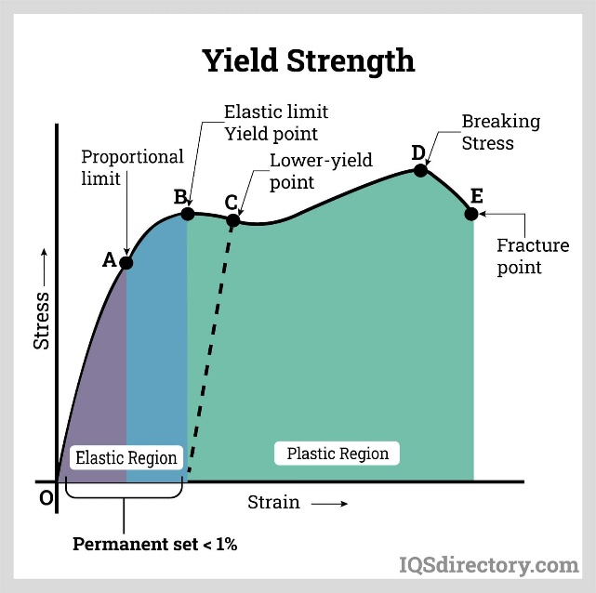

Although the 0.2% offset was chosen somewhat arbitrarily, it is now a commonly recognized norm in materials testing. It offers a reliable and consistent method of calculating the yield strength without depending on a particular point on the curve that could be noisy or variable.